Game Design Document

Fill up the Following document

1. Write the title of your project.

Dr. Driving

1. What is the goal of the game?

The goal of the game is that the player has to keep going without crashing any obstacles to the finish line.

1. Write a brief story of your game?

The driver is on the road driving as he wants to reach the airport(finish line) as soon as he can as he has his flight. Can you make him reach in time?

1. Which are the playing characters of this game?

* Playing characters are the ones which respond to the user based on the input from the user
* Cars, monkeys, dinos, wizards etc, are the playing characters in the game.

|  |  |  |
| --- | --- | --- |
| Number | Character Name | What can this character do? |
| 1 | Car | It can move right and left to dodge the non-playing cars. |
| 2 |  |  |
| 3 |  |  |
| 4 |  |  |
| 5 |  |  |
| 6 |  |  |
| 7 |  |  |
| 8 |  |  |

1. Which are the Non Playing Characters of this game?

* Non Playing characters are the ones which don't have an action or a behaviour when the user interacts with the game.
* Hurdles, stones, bananas, coins, etc are non playing characters in the game.

|  |  |  |
| --- | --- | --- |
| Number | Character Name | What can this character do? |
| 1 | Vehicle1 | Will try to crash to the Player |
| 2 | Vehicle2 | Will try to crash to the Player |
| 3 | Vehicle3 | Will try to crash to the Player |
| 4 | Vehicle4 | Will try to crash to the Player |
| 5 | Vehicle5 | Will try to crash to the Player |
| 6 | Vehicle6 | Will try to crash to the Player |
| 7 |  |  |
| 8 |  |  |

Draw your imagination of this game. What does this game look like?

* Draw the game either on your computer or on paper,
* Add images of scenes of the game to show each of the playing and non-playing characters at least once.

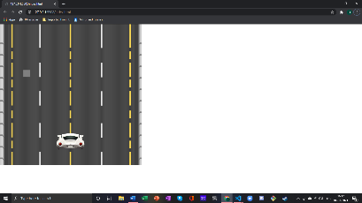PLEASE NOTE THIS IS NOT THE READY VERSION.

How do you plan to make your game engaging?

I have added the images and start adding and editing others at home.I will try to do my work at my home as much as possible or in the classes. I have a fresh idea in my mind and I am ready to execute that.